

**Table Of Contents**

**1. Introduction 4**

1.1. Problem Statement 4

**2. Functional Requirements 5**

2.1. Admin Management 5

2.2. Doctor Management 5

2.3. Patient Management 5

**3. Non-Functional Requirements 6**

3.1. Performance Requirements 6

3.2. Safety Requirements 6

3.3. Security Requirements 6

3.4. Software Quality Attributes 6

3.5. Business Rules 6

**4. User Stories 6**

**5. Product Backlog 7**

**6. Sprint 1 Backlog 9**

**7. Sprint 2 Backlog 10**

**8. Sprint 3 Design 11**

8.1. Sprint 3 Items 13

8.2. Design Details 14

8.2.1. Assign Shifts to Doctors: 14

8.2.2. Schedule an Appointment: 14

8.2.3. Cancel an Appointment: 14

8.2.4. Give Feedback on Appointment: 14

8.2.5. View Feedback Related to Appointments: 14

8.2.6. Reschedule an Appointment: 14

8.2.7. Update Appointment Completion Status and Availability: 15

**9. System Architecture and Project Plan 15**

**10. Actual Implementation 15**

10.1. Common Login Page 15

10.2. Admin’s Pages 15

10.3. Patient’s Pages 15

10.4. Doctor’s Pages 15

10.4.1. Doctor Dashboard 15

10.4.2. Doctor Appointments Page 15

10.4.3. Doctor Shifts Page 15

10.4.4. Doctor Feedback Page 15

10.4.5. Doctor Profile Page 15

**11. Product Burndown Chart 16**

**12. Sprint 3 Burndown Chart 16**

**13. Trello Board 17**

13.1. Sprint 1 Start 17

13.2. Sprint 2 End 17

13.3. Sprint 3 End 18

**14. Black Box Testing 20**

**15. White Box Testing 21**

**16. Work Division 21**

16.1. Mavra Mehak Gill - 22i-0798 21

16.1.1. Contribution Area 21

16.1.2. Details 21

16.2. Maryum Tanvir - 22i-0751 22

16.2.1. Contribution Area 22

16.2.2. Details 22

16.3. Salman Khan - 22i-1285 22

16.3.1. Contribution Area 22

16.3.2. Details 22

**17. Lesson Learnt 23**

# Introduction

The Ikigai/I-CARE Clinic Appointment Management System is a full-stack web application developed to streamline hospital operations by centralizing functions, reducing manual errors, and improving communication. Designed with the needs of admins, doctors, and patients in mind, the system provides a seamless platform for appointment scheduling, doctor management, patient registration, shift assignments, and feedback collection.

Built using the MERN stack — MongoDB, Express.js, React.js, and Node.js, the application follows the MVC architecture to ensure a clean separation of concerns and scalable development practices. The frontend offers an intuitive and responsive interface for users, while the backend provides robust APIs to handle business logic and database operations.

## Problem Statement

| **The problem of** | Clinics generate significant amounts of operational data but often rely on manual processes for managing appointments, doctor schedules, patient registration, and feedback. This leads to scheduling errors, patient dissatisfaction, inefficient use of staff time, and revenue losses. |
| --- | --- |
| **affects** | Doctors, Administrators, and Patients. |
| **the impact of which is** | Reduced quality of patient care, delayed treatments, increased costs, scheduling conflicts, and inefficient inventory management. |
| **a successful solution would be** | **I-CARE** is a comprehensive, centralized **Clinic Appointment Management System** designed to digitize and streamline all clinic operations. It integrates patient registration, appointment scheduling, doctor management, shift assignment, payment processing, and feedback collection into a single easy-to-use platform. By providing real-time access to available doctors, upcoming appointments, and pending actions, I-CARE ensures that clinics run efficiently, patients are cared for promptly, and doctors’ time is utilized optimally. |

I-CARE addresses common challenges faced in traditional hospital setups, such as inefficient scheduling, lack of transparency in doctor availability, and delayed feedback loops. The system incorporates features like user authentication, doctor profile management, shift scheduling, appointment tracking, payment integration, and feedback collection.

The project was developed using an agile methodology in a team of three students, progressing through multiple sprints. Each sprint focused on delivering key features iteratively, with continuous integration and testing to ensure quality and usability. I-CARE not only digitizes hospital management but also demonstrates the team’s understanding of modern web development practices and software engineering principles.

# Functional Requirements

## Admin Management

* Admins should be able to update or remove doctor profiles.
* Admins should be able to approve doctors with verified credentials.
* Admins should be able to assign shifts to doctors.

## Doctor Management

* Doctors should be able to filter, view & update past, present and future appointments
* Doctors should be able to provide medical notes & update appointment completion status.
* Doctors should be able to update their availability.
* Doctors should be able to filter & view their assigned shifts.
* Doctors should be able to update & view appointment feedback.

## Patient Management

* Patients should be able to register in the system.
* Patients should be able to filter & view available doctors.
* Patients should be able to schedule, cancel, and reschedule appointments.
* Patients should be able to provide feedback.
* Patients should be able to pay & view consultation fees.
* Patients should be able to track appointment history.

# Non-Functional Requirements

## Performance Requirements

* The system shall respond to 90% of user requests within 2 secondsunder normal load conditions.

## Safety Requirements

* The system shall ensure that user data (e.g., patient records, doctor credentials) is stored securely to prevent unauthorized access

## Security Requirements

* All patient data should be encrypted using JWT authentication and bcrypt encryption.
* The system shall implement user roles and permissions to restrict access to sensitive data and functions (e.g., only admins can manage doctor profiles)

## Software Quality Attributes

* The system shall have a user-friendly interface that is easy to navigate and understand for admins, doctors, and patients.
* The system shall provide clear and helpful error messages to guide users in case of problems.
* The system shall be designed in a modular way to facilitate future maintenance and updates.
* The web application should have a responsive design, supporting desktop, tablet, and mobile devices

## Business Rules

* The system shall enforce that only verified doctors can be granted access to the system.
* The system shall ensure that patients can only book appointments with available doctors and time slots

# User Stories

(Paste Blocked User Stories here or merge word file here)

# Product Backlog

# 

| **Item ID** | **Type of Backlog Item** | **Description** | **Priority** | **Status** | **Sprint** | **Assigned** | **Acceptance Criteria** |
| --- | --- | --- | --- | --- | --- | --- | --- |
| 1 | User Story | Update or remove doctor profiles | Medium | Completed | Sprint 1 | Maryum Tanvir | Admin can update/remove doctor profiles and receive confirmation |
| 2 | User Story | Approve doctors with verified credentials | Medium | Completed | Sprint 2 | Maryum Tanvir | Admin can review and approve doctors, granting system access |
| 3 | User Story | Filter, view assigned shifts as a doctor | Medium | Completed | Sprint 1 | Salman Khan | Doctor sees past/current/ future assigned shifts with date/time details |
| 4 | User Story | Assign shifts to doctors | High | Completed | Sprint 3 | Maryum Tanvir | Admin assigns shifts, and system updates doctor's schedule |
| 5 | User Story | Filter, view available doctors as a patient | High | Completed | Sprint 1 | Mavra Mehak | Patient searches for doctors by specialty/availability |
| 6 | User Story | Register as a patient | High | Completed | Sprint 2 | Mavra Mehak | Patient fills form, gets registered, and receives login credentials |
| 7 | User Story | Schedule an appointment | High | Completed | Sprint 3 | Mavra Mehak | Patient selects doctor/time, appointment is confirmed |
| 8 | User Story | Cancel an appointment | Medium | Completed | Sprint 3 | Mavra Mehak | Patient cancels appointment, slot becomes available |
| 9 | User Story | Filter, view upcoming appointments as a doctor | Medium | Completed | Sprint 1 | Salman Khan | Doctor sees upcoming appointments with patient details |
| 10 | User Story | Search and view doctors for managing them | Medium | Completed | Sprint 1 | Maryum Tanvir | Admin can search doctors they want to edit to remove |
| 11 | User Story | Filter, view past and upcoming appointments as a patient | High | Completed | Sprint 1 | Mavra  Mehak | Patient sees past/future appointments, data is accurate |
| 12 | User Story | Submit feedback after an appointment | low | Completed | Sprint 3 | Mavra  Mehak | Patient submits feedback, stored in system |
| 13 | User Story | Update & View feedback as a doctor | low | Completed | Sprint 3 | Salman Khan | Doctor sees patient comments and ratings and acknowledges it |
| 14 | User Story | View consultation fee online | Medium | Completed | Sprint 2 | Mavra Mehak | Patient sees bill in payment section |
| 15 | User Story | Reschedule an appointment | low | Completed | Sprint 3 | Mavra  Mehak | Patient selects new time, system updates appointment |
| 16 | User Story | Update appointment completion status as a doctor | Medium | Completed | Sprint 3 | Salman Khan | Doctor marks appointment completed, availability updates |
| 17 | UI | Login/ Register  Pages | High | Completed | Sprint 2 | Salman Khan | Any User can Register their Account or Login |

**Key:**

High

Medium

low

# Sprint 1 Backlog

| **Item ID** | **Type of Backlog Item** | **Description** | **Priority** | **Status** | **Sprint** | **Assigned** | **Acceptance Criteria** |
| --- | --- | --- | --- | --- | --- | --- | --- |
| 1 | User Story | Update or remove doctor profiles | Medium | Completed | Sprint 1 | Maryum Tanvir | Admin can update/remove doctor profiles and receive confirmation |
| 3 | User Story | Filter, view assigned shifts as a doctor | Medium | Completed | Sprint 1 | Salman Khan | Doctor sees past/current/ future assigned shifts with date/time details |
| 5 | User Story | Filter, view available doctors as a patient | High | Completed | Sprint 1 | Mavra Mehak | Patient searches for doctors by specialty/availability |
| 9 | User Story | Filter, view upcoming appointments as a doctor | Medium | Completed | Sprint 1 | Salman Khan | Doctor sees upcoming appointments with patient details |
| 10 | User Story | Filter, view past and upcoming appointments as a patient | High | Completed | Sprint 1 | Mavra  Mehak | Patient sees past/future appointments, data is accurate |
| 16 | UI | Login/ Register  Pages | High | Completed | Sprint 2 | Salman Khan | Any User can Register their Account or Login |

## 

## 

## 

## 

**Key:**

High

Medium

low

# Sprint 2 Backlog

| **Item ID** | **Type of Backlog Item** | **Description** | **Priority** | **Status** | **Sprint** | **Assigned** | **Acceptance Criteria** |
| --- | --- | --- | --- | --- | --- | --- | --- |
| 2 | User Story | Approve doctors with verified credentials | Medium | Completed | Sprint 2 | Maryum Tanvir | Admin can review and approve doctors, granting system access |
| 6 | User Story | Register as a patient | High | Completed | Sprint 2 | Mavra Mehak | Patient fills form, gets registered, and receives login credentials |
| 13 | User Story | View consultation fee online | Medium | Completed | Sprint 2 | Mavra Mehak | Patient sees bill in payment section |
| 16 | UI | Login/ Register  Pages | High | Completed | Sprint 2 | Salman Khan | Any User can Register their Account or Login |

**Key:**

High

Medium

low

# Sprint 3 Design

# 

| **Item ID** | **Type of Backlog Item** | **Description** | **Priority** | **Status** | **Sprint** | **Assigned** | **Acceptance Criteria** |
| --- | --- | --- | --- | --- | --- | --- | --- |
| 4 | User Story | Assign shifts to doctors | High | Completed | Sprint 3 | Maryum Tanvir | Admin assigns shifts, and system updates doctor's schedule |
| 7 | User Story | Schedule an appointment | High | Completed | Sprint 3 | Mavra Mehak | Patient selects doctor/time, appointment is confirmed |
| 8 | User Story | Cancel an appointment | Medium | Completed | Sprint 3 | Mavra Mehak | Patient cancels appointment, slot becomes available |
| 11 | User Story | Submit feedback after an appointment | low | Completed | Sprint 3 | Mavra  Mehak | Patient submits feedback, stored in system |
| 12 | User Story | Update & View feedback as a doctor | low | Completed | Sprint 3 | Salman Khan | Doctor sees patient comments and ratings and acknowledges it |
| 14 | User Story | Reschedule an appointment | low | Completed | Sprint 3 | Mavra  Mehak | Patient selects new time, system updates appointment |
| 15 | User Story | Update appointment completion status as a doctor | Medium | Completed | Sprint 3 | Salman Khan | Doctor marks appointment completed, availability updates |

**Key:**

High

Medium

low

## Sprint 3 Items

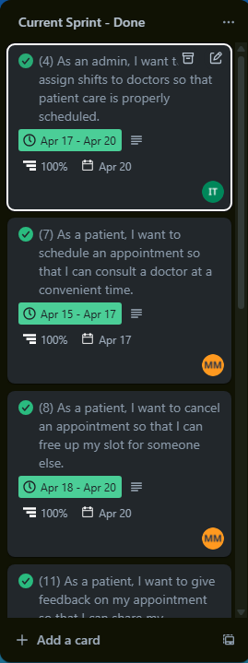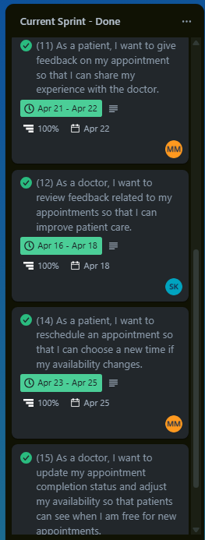

## Design Details

### **Assign Shifts to Doctors:**

This feature enables admins to schedule shifts for doctors by accessing a shift scheduling module, ensuring proper patient care coverage through an intuitive interface that displays doctor availability and shift details.

### **Schedule an Appointment:**

This functionality allows patients to book appointments by selecting a doctor and an available time slot, with the system confirming the appointment and updating the doctor's schedule in real time.

### **Cancel an Appointment:**

This feature permits patients to cancel their scheduled appointments, freeing up the slot for others while automatically updating the doctor’s availability to reflect the change.

### **Give F**eedback on Appointment:

This feature allows patients to submit feedback after completing an appointment, which is then recorded for doctor review.

### **View Feedback Related to Appointments:**

This functionality enables doctors to access patient feedback on their appointments, displaying comments and ratings to help improve patient care.

### **Reschedule an Appointment:**

This feature allows patients to modify their appointment time by selecting a new available slot, ensuring the system updates the appointment details and doctor’s schedule accordingly.

### **Update Appointment Completion Status and Availability:**

This feature enables doctors to mark appointments as completed, automatically adjusting their availability based on their configured schedule to reflect open slots for new appointments.

# System Architecture and Project Plan

(Reference to System Architecture & Project Plan reports)

# Actual Implementation

## Common Pages

### 10.1.1 Login Page

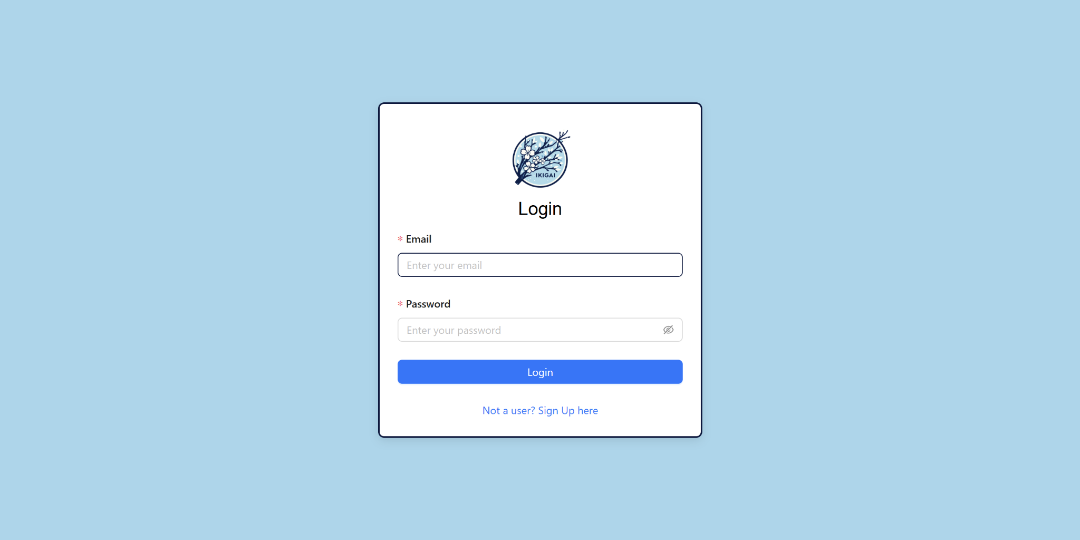

### 10.1.2 Sign Up Page

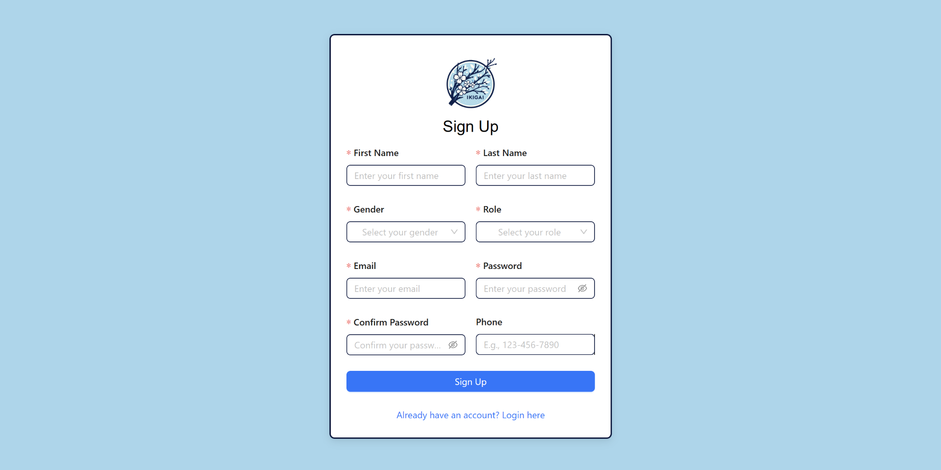

## Admin’s Pages

### 10.2.1 Admin’s Dashboard

### 

### 

### 

### 

### 

### 

### 

### 10.2.2 Admin Manage Doctors Page

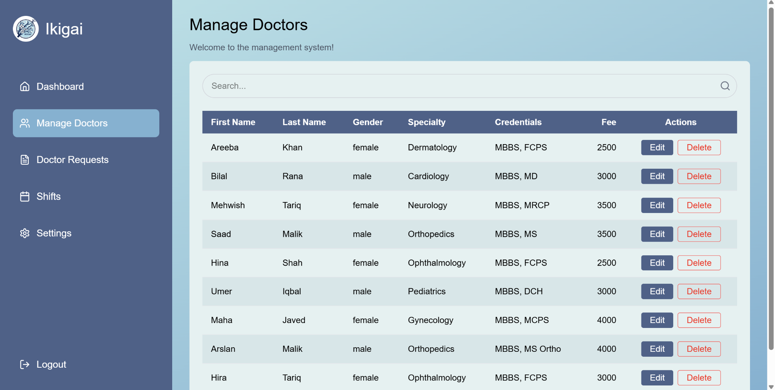

### 10.2.3 Admin Manage Doctors Request

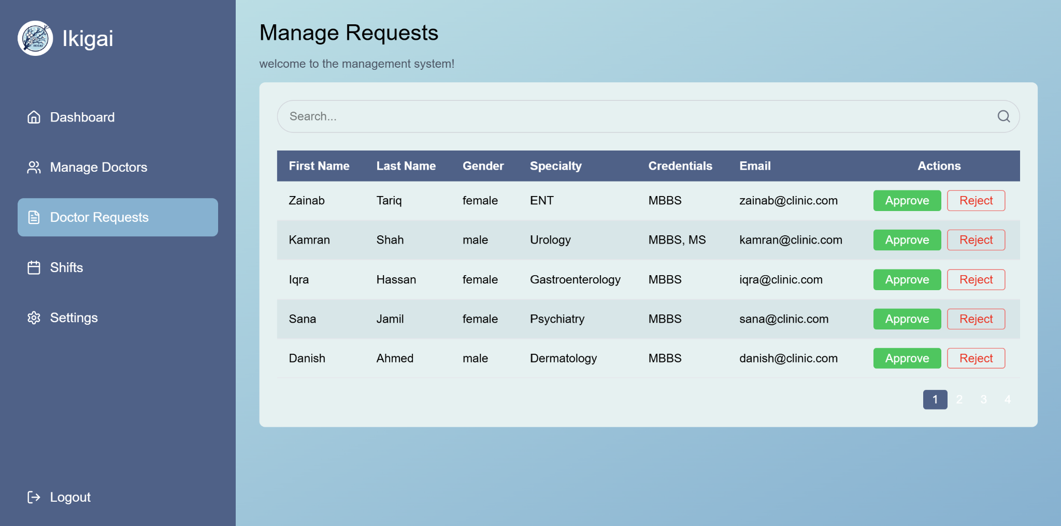

### 10.2.4 Admin Assign Shift Page

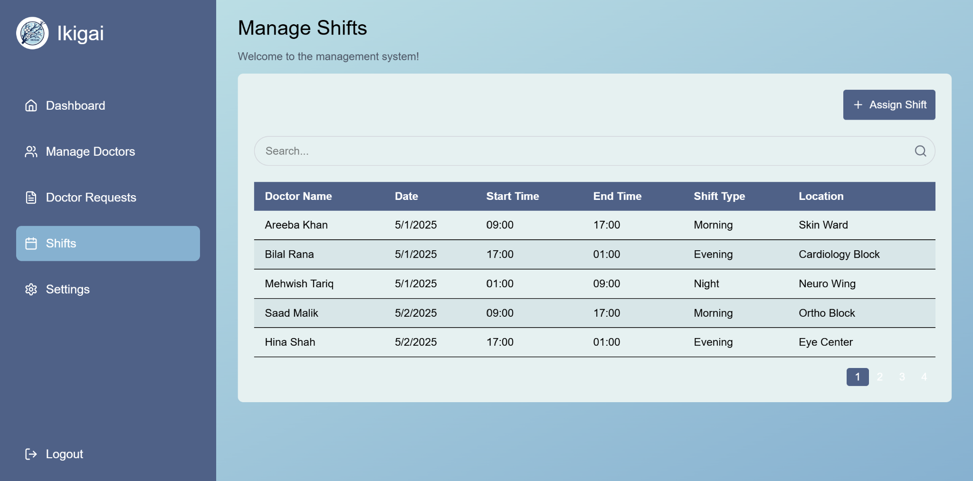

### 10.2.5 Admin Settings Page

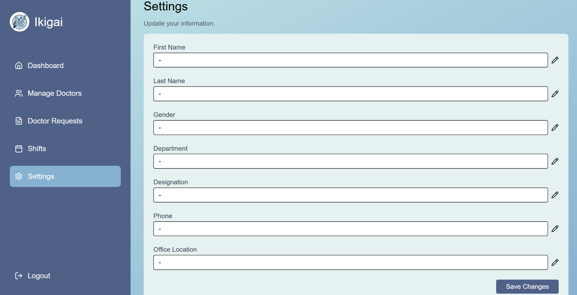

## Patient’s Pages

### Patient Dashboard

### Patient Appointments Page

### Patient Doctors/Book Appointments

### Patient Payments

### Patient Feedback

### Patient Profile

## Doctor’s Pages

### Doctor Dashboard

(will put when db has enough insertions so GUI looks filled)

### Doctor Appointments Page

(will put when db has enough insertions so GUI looks filled)

### Doctor Shifts Page

(will put when db has enough insertions so GUI looks filled)

### Doctor Feedback Page

(will put when db has enough insertions so GUI looks filled)

### Doctor Profile Page

(will put when db has enough insertions so GUI looks filled)

# Sprint 3 Burndown Chart

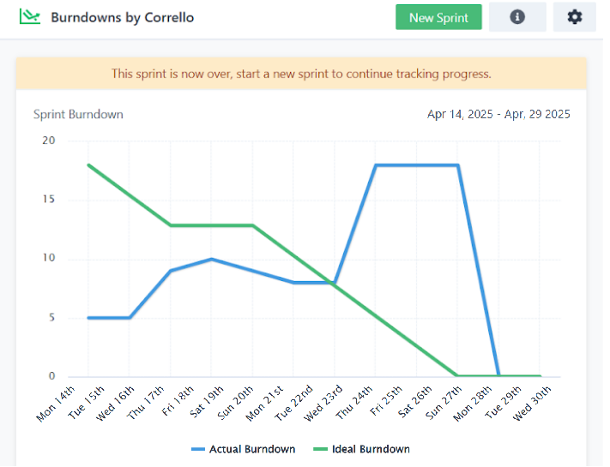

# Trello Board

## Sprint 1 Start

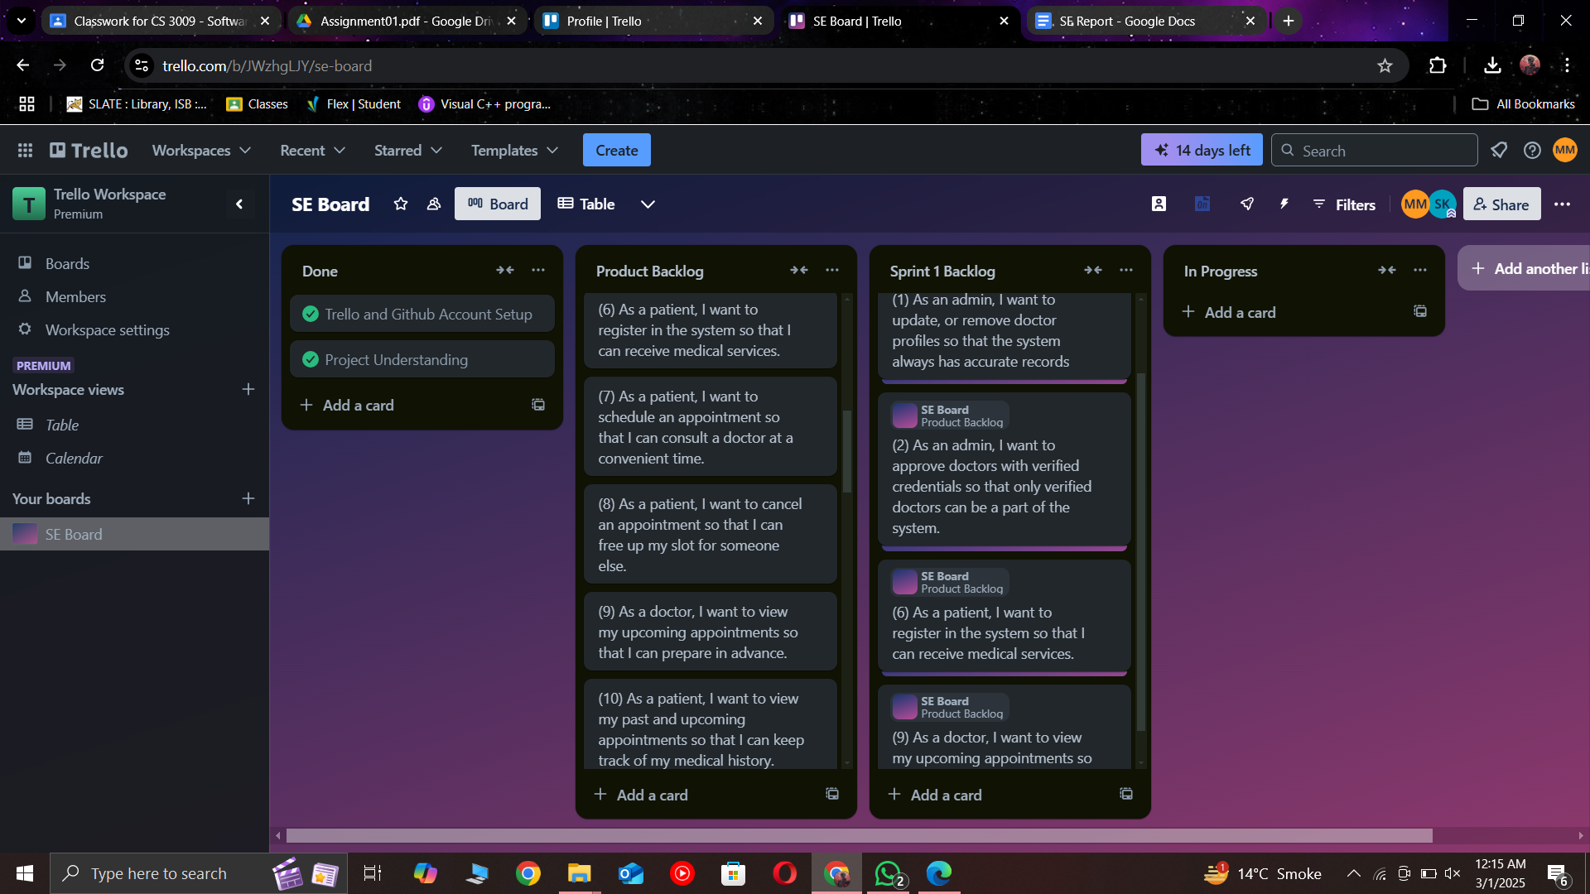

## Sprint 2 End

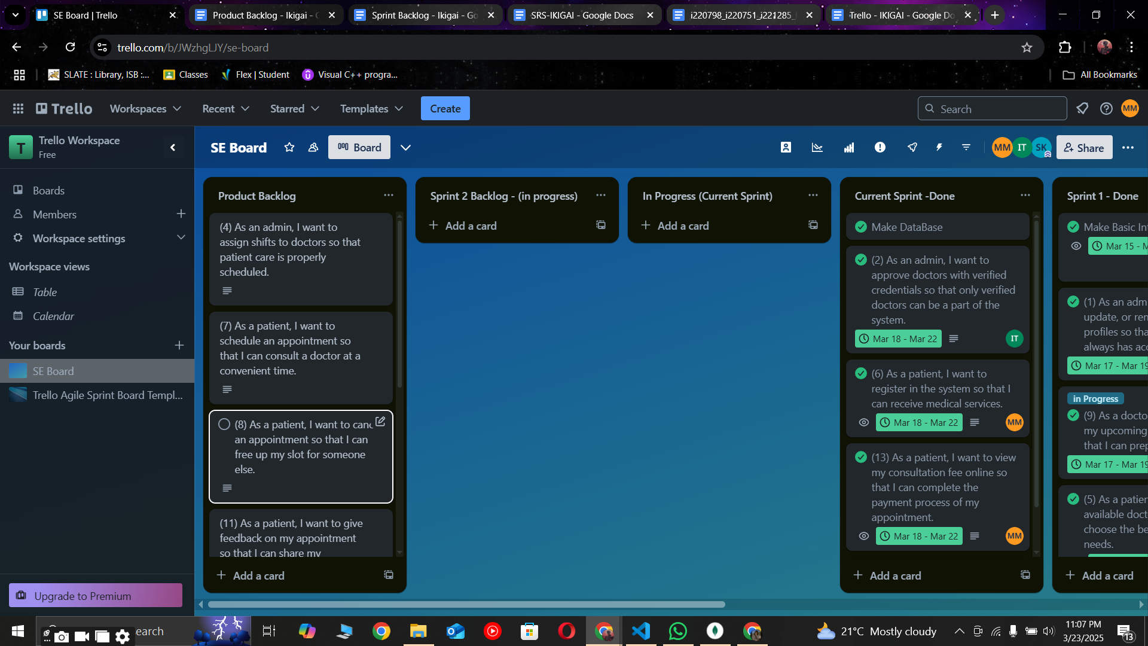

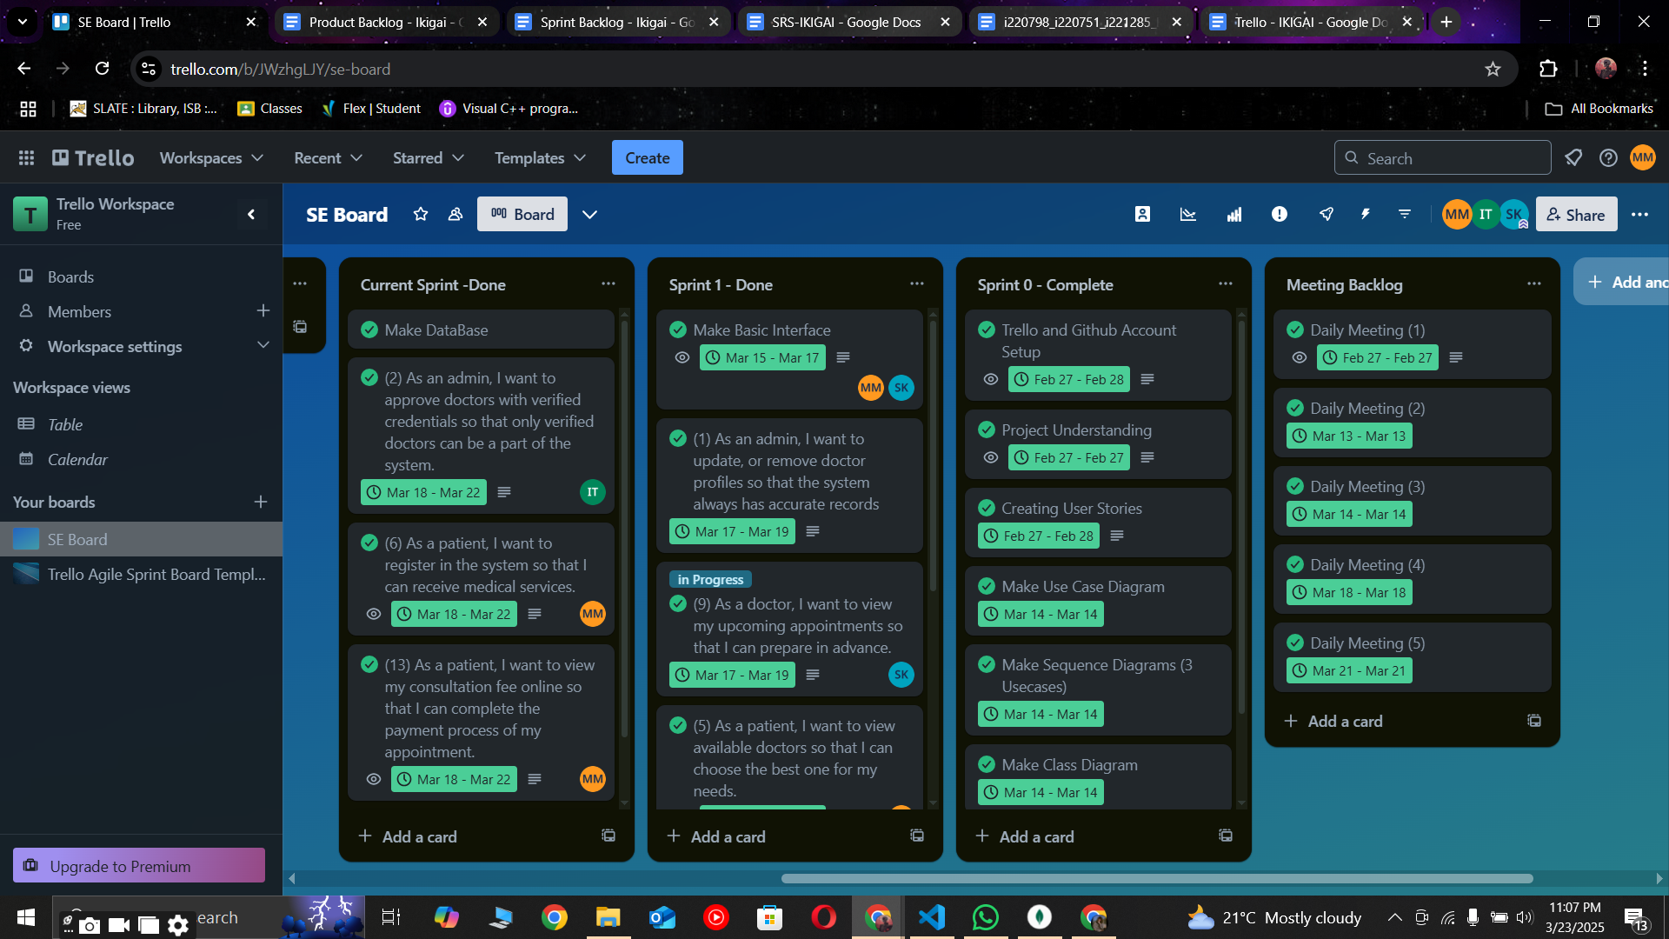

## Sprint 3 End

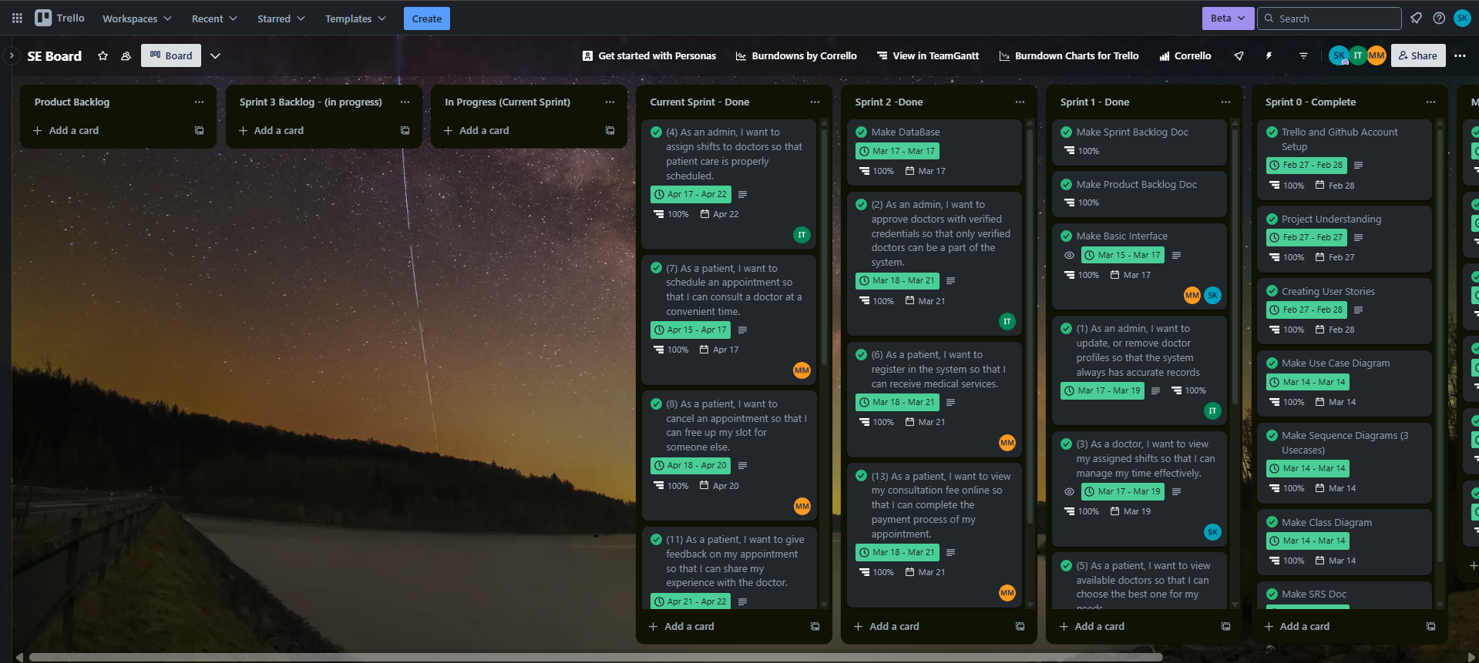

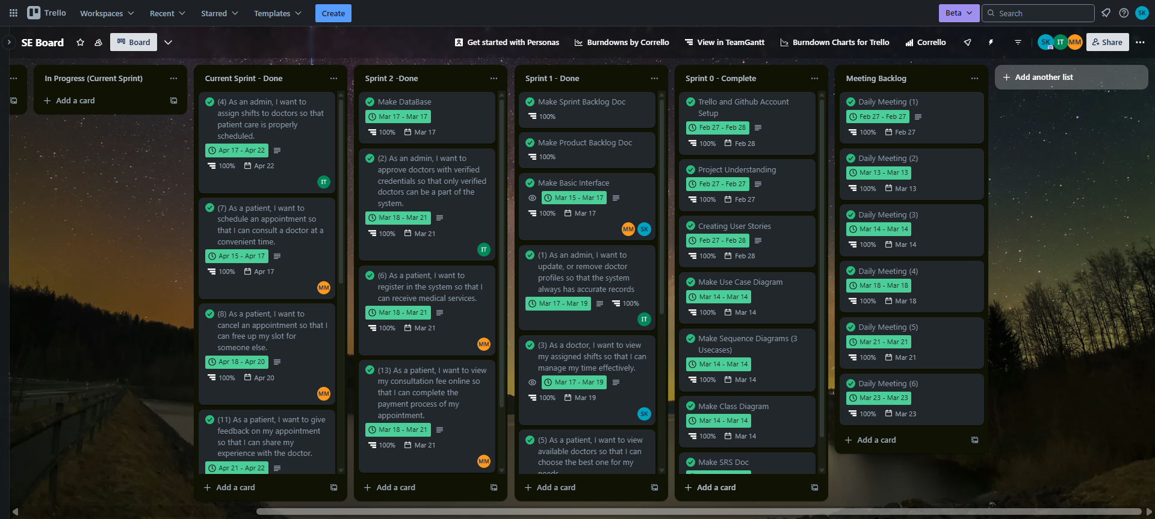

# Black Box Testing

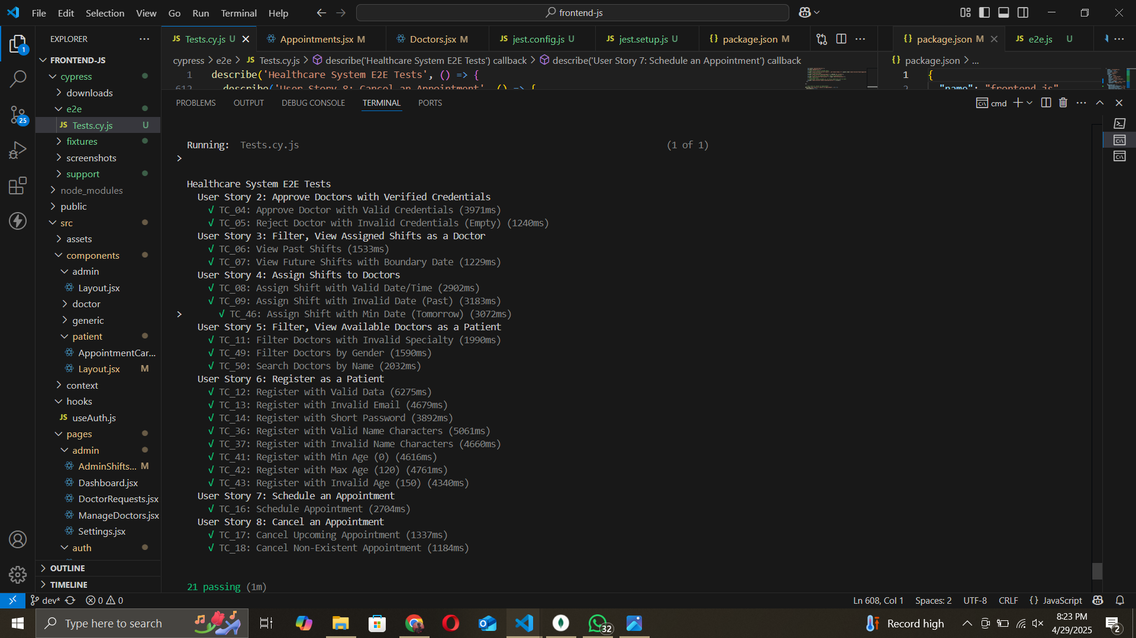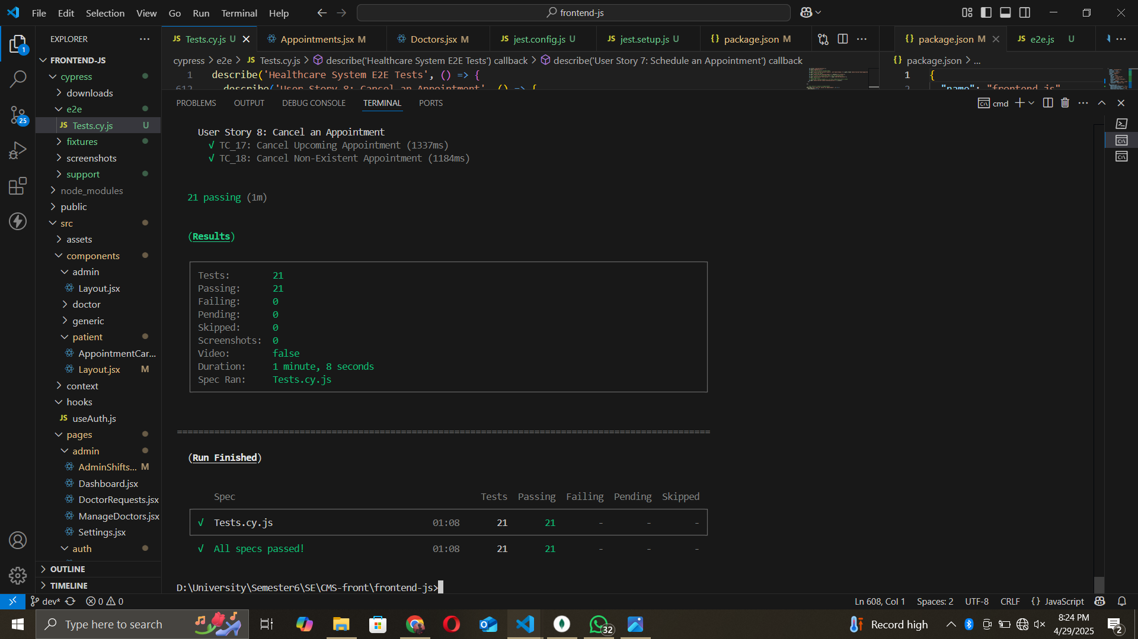

# White Box Testing

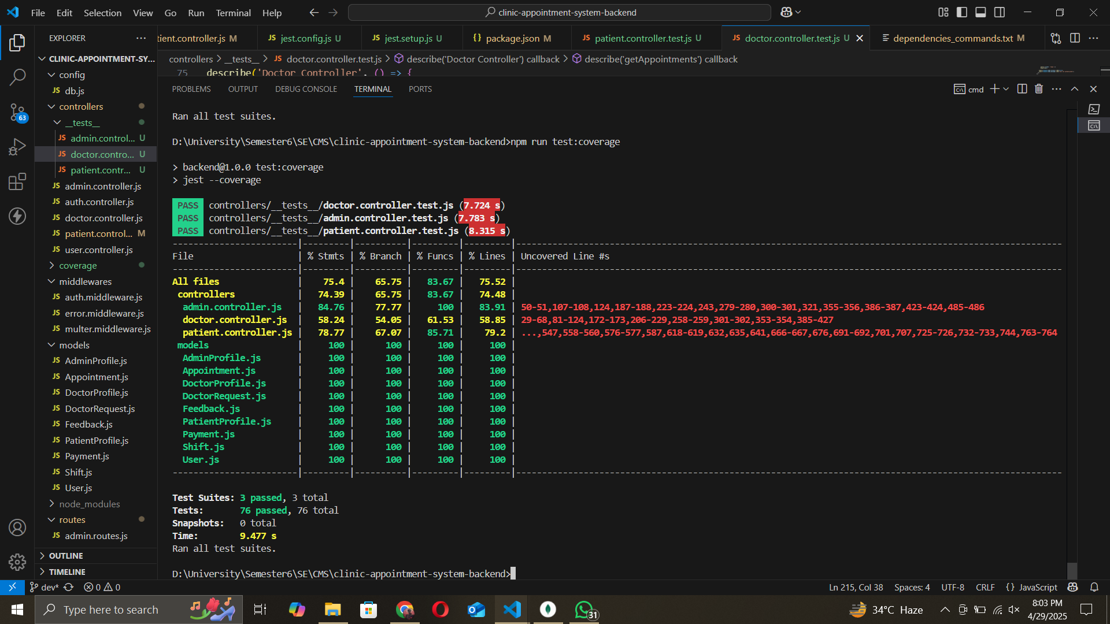

# Work Division

## Mavra Mehak Gill - 22i-0798

### Contribution Area

Scrum Master Duties, Frontend + Backend Development (Patient Features), Testing, UI Design

### Details

Mavra focused on developing all patient-related pages, including patient registration, viewing available doctors, scheduling, canceling, rescheduling appointments, viewing consultation fees, tracking appointment history, and submitting feedback (**User Stories 5, 6, 7, 8, 10, 11, 13, 14**). She conducted extensive testing, writing and executing black-box and white-box test cases to ensure the reliability of patient-facing features. Mavra also contributed to 50% of the overall UI design, creating a user-friendly and responsive interface. As the Scrum Master, she managed the project timeline, divided tasks, facilitated daily meetings, and ensured timely sprint deliveries using agile practices.

## Maryum Tanvir - 22i-0751

### Contribution Area

Frontend + Backend Development (Admin Features), Database Schema Design, UI Design, API Testing, GitHub Maintenance

### Details

Maryum focused on implementing all admin-related user stories, including updating or removing doctor profiles, approving doctors with verified credentials, and assigning shifts to doctors (**User Stories 1, 2, 4**). She designed the database schema for the application using MongoDB, ensuring efficient storage and retrieval of data for doctors, patients, and appointments. Maryum also contributed the remaining 50% of the overall UI design, collaborating with Mavra to create a cohesive and responsive interface. She assisted in testing by developing test cases to validate admin functionalities and maintained the GitHub repository, managing commits and ensuring version control after each sprint.

## Salman Khan - 22i-1285

### Contribution Area

Frontend + Backend Development (Doctor Features), Authentication Module (Signup/Login), Documentation, Trello Board Maintenance

### Details

Salman focused on implementing all doctor-related user stories, including viewing assigned shifts, viewing upcoming appointments, viewing feedback, and updating appointment completion status and availability (**User Stories 3, 9, 12, 15**). He also developed the signup and login pages for all user roles, ensuring secure authentication and proper form validation. Additionally, Salman was responsible for creating and maintaining the project documentation, ensuring all reports were comprehensive and up to date. He also managed the Trello board, keeping tasks organized and tracking sprint progress

# Lesson Learnt

Throughout the development of the Ikigai/I-CARE project, the team gained valuable experience in both technical and collaborative aspects. On the technical side, we learned the importance of modular architecture and clean code practices, especially when working with MERN stack, as it ensured that the project remained scalable and maintainable. We also gained a deeper understanding of frontend-backend integration. Another key lesson was the significance of unit testing and test coverage—we realized that writing comprehensive test cases requires accounting for edge cases, interactions between components, and asynchronous behaviors, which was more challenging than anticipated.

On the collaborative side, we learned the importance of clear communication and task distribution, ensuring that each team member’s strengths were leveraged effectively. Time management and consistent project planning through tools like Trello and Gantt charts played a crucial role in keeping the development process on track. Using GitHub taught us how to collaborate better, from managing commits to resolving merge conflicts, making teamwork smoother.

This project taught us how to balance individual and team responsibilities, tackle challenges together, and grow as developers. We’re proud of what we achieved and we hope to continue refining our skills to craft even more optimized, robust and complex web applications.

# Links

## Github Version Control

**Front End:**

<https://github.com/MaryumTanvir/clinic-appointment-system-frontend.git>

**Back End:**

<https://github.com/MaryumTanvir/clinic-appointment-system-backend.git>

## Vercel Live Demo

<https://clinic-appointment-management-system-frontend.vercel.app/>

## Presentation

<https://www.canva.com/design/DAGS6t6nNVY/eYhEsgE7rmcZjZe9ZflXaA/edit>